Abstract Title
Onur Yesil¹, Bulent Babaoglu² and Tevfik Patan³*
¹Affiliation, Centered , Italic, Times New Roman 8
²Affiliation if different from 1, Centered, Italic, Times New Roman 8
³Affiliation if different from 1 and/or 2, Centered, Italic, Times New Roman 8
*Corresponding author, only@email.tr, Centered, Italic, Times New Roman 8
Keywords: List 4-5 keywords separated by commas and ending with a stop.
Abstract
This one-page abstract will be published in the conference documentation. The abstract should be at least 150 words, but not exceed one page (font size: 11 points, aligned: justify). Paper size should be A4 (21.0 cm x 29.7 cm). Page margins should be 2.5 cm for the left, right, top and bottom margins. Use font type ‘Times New Roman’ with single spaced lines. The title of the paper (font size: 14 points, bold, first capital of every word, aligned: center) can use a maximum of two rows. Use 12 points spacing before and after the title of the paper. Use 24 points before and 12 points after the heading of the abstract (font size: 11 points, bold, first capital, aligned: left).
All tables and figures must be cited before they are used in the abstract and must be horizontally centered on the page (Figure 1a and 1b). Use 11 points spacing before figure and after caption of the figure. Use 11 points spacing before table caption and after the table.

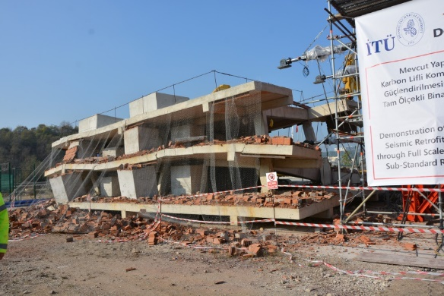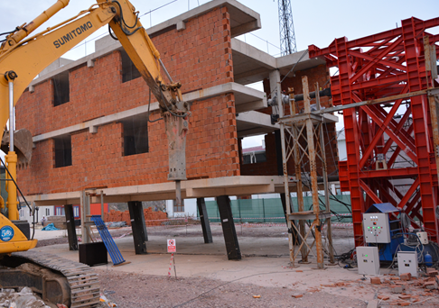
a) b)
Figure 1. Test buildings, a) collapsed reference building, b) deformed shape of FRP retrofitted building.

